The logo is for an app which is capable of spotting animals in Sri Lankan national parks and uploading them. Because it has a focus on the native animals in Sri Lanka, I designed the logo around a native animal, the Sri Lanka Leopard.

Rather than having a picture of the Leopard, which would be a complex image (rather than a simple logo), I decided to use photoshop to make the picture more cartoon-like, and focus on the shapes that make up the leopard’s face.

Design process: original image

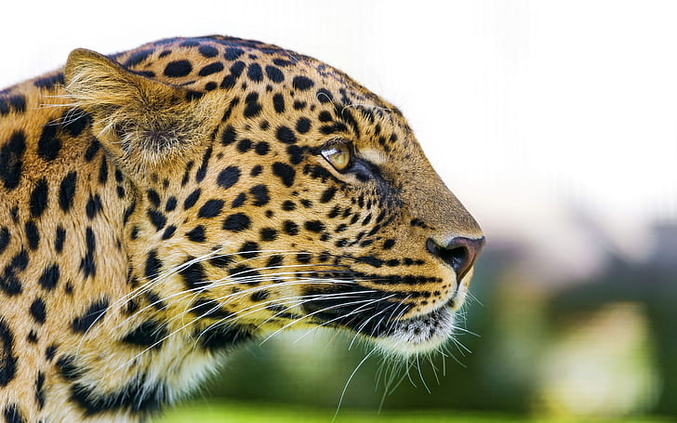

After using photoshop: I added a swirl pattern to create a nice effect, but then decided that the image was a little too bright.

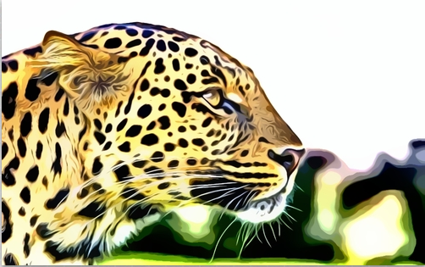

I also further blurred the background to take attention away from the trees and towards the leopard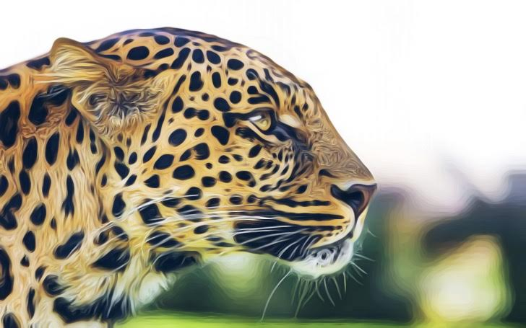

I then cropped the image into a square so it would fit the guidelines. To do this I added pixels to the top, then cropped the image.



To make sure all important parts of the image can be seen on the app interface (as it is in a circle), I placed it in a circle, then on the app interface.

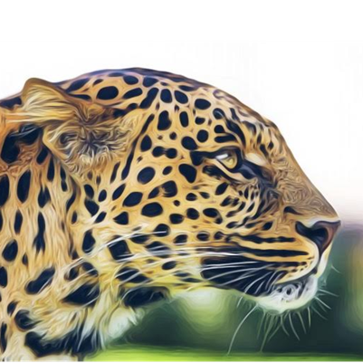

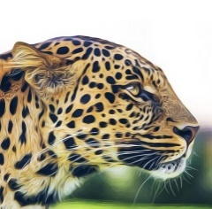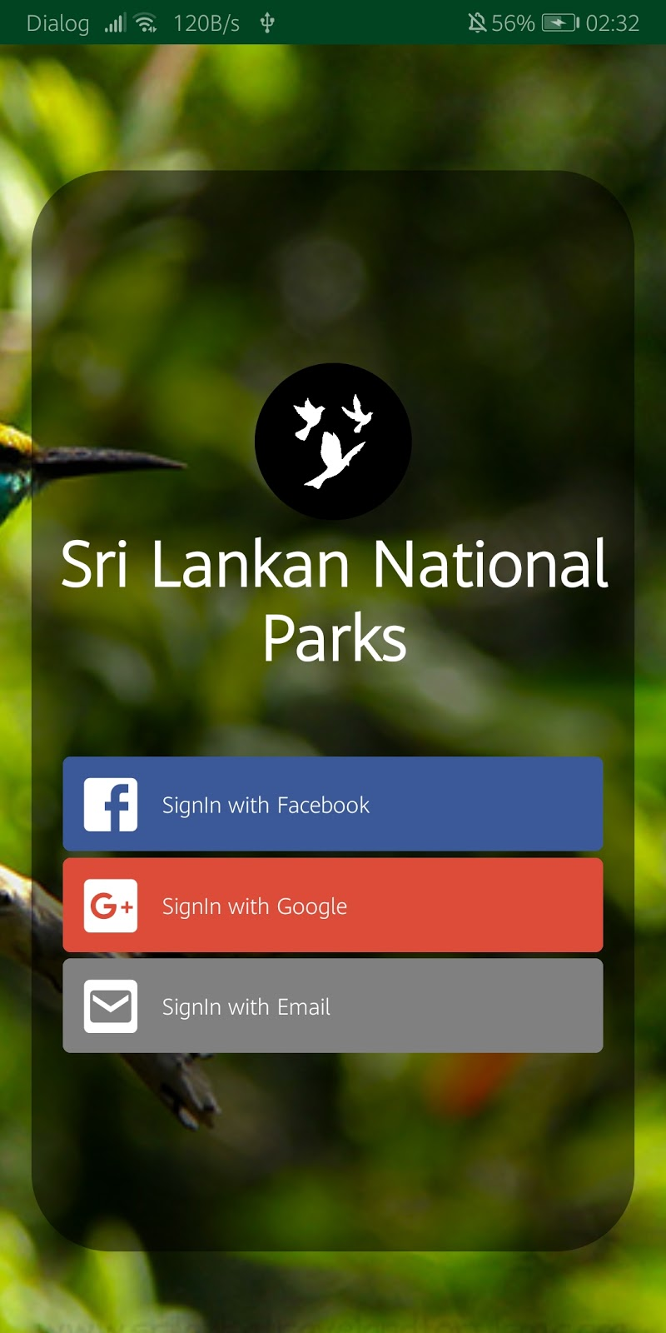

As can be noted, the logo fits in well with the color scheme of the app interface, and is appealing to the user, making it effective.

Logo in black and white/SVG format

